Analyzing FEWarp Models in PostView
  - Using PostView 2.5

Introduction
A warping analysis requires image data, in addition to an FE model. The FE model depends on this image data, in the sense that its deformation is determined primarily by the difference between the target and template image data. As a result, it might be important to visualize the FE results adjacent to the image data. PostView has several tools that allows users to visualize image data and these tools are described in this document, with a particular emphasis on the visualization and analysis of warping results.

The PostView Session File
As a first step, the FE model and all dependent image data need to be loaded into PostView. In the next section, a detailed account is given on how to import model data and image data separately, however, in practice, the session file will provide a convenient shortcut to load all data at once.
The session file is an xml-formatted text file that lists all the components that will be loaded into a PostView model. Although the session file can store a lot more than described here, for the purpose of loading the results of a warping analysis, the following is an example of a minimal session file.
<?xml version="1.0" encoding="utf-8"?>
<postview_spec>
<Model file="heart1.xplt">
<ImageStack id="1" name="template">
<file>temp.raw</file>
<size>64,64,8</size>
<box>0, 0, 0, 9.35, 9.35, 7</box>
</ImageStack>
<ImageStack id="2" name="target">
<file>study.raw</file>
<size>64,64,8</size>
<box>0, 0, 0, 9.35, 9.35, 7</box>
</ImageStack>
</Model>
</postview_spec>
The Model tag defines the FEBio plotfile with the filename specified by the file attribute. Note that the filename can be given using an absolute path, or, as in the example above, using just the file title. In the latter case it is assumed that the plotfile resides in the same folder as the session file.
A warping model usually requires at least two image data sets, one for the template, and one for the target. Each image set is defined by an ImageStack section in the session file (Note that each ImageStack is a child of the Model tag). For each image data set, the user needs to specify the file name, the image dimensions, and the physical dimensions that map the image data into the global space of the FE model. Note that the size tag always has to be three numbers, defining the x, y, and z pixel resolution of the image. For 2D images, set the z-resolution to 1.
Each image set can also be given a name, via the name attribute. This is the name that will be displayed in PostView’s model viewer. Although users can enter any name here, for warping analysis, it will be convenient to use the name attribute to identify the template and target.
If a warping analysis uses multiple targets, each target can be loaded using a separate ImageStack for each target. Again, the name attribute can be used to identify each target uniquely in the model viewer.
To open a session file in PostView, go to the File\Open Session menu item, and select the pvs file from the file open dialog box that appears.

Loading Image Data
Although the session file described above is the most convenient way for loading warping models into PostView, image data can also be imported separately. Before you can load image data, you need to load a plotfile first. This can be done via the File\Open menu or the corresponding toolbar button on the main toolbar, or via the File Viewer panel. Since this process is described in detail in the PostView user manual, we will not describe it here and focus on loading image data.
To load an image data set, click on the Tools panel and then on the “Add 3D image” tool button. In the pane that appears below the tool buttons, you can select an image file (by clicking the ellipsis next to the File field), enter the image size (X-pixels, Y-pixels, Z-pixels) and the physical dimensions (x-min, x-max, etc.). Note that, for now, PostView only supports 8-bit RAW image data. Then, click the load button to import the data into the current model. (Since PostView 2.5 can have multiple models open at once, make sure the correct model is active before adding image data.) If the load is successful, a new item will be added to the Model Viewer. The default name of this item will be the file title of the corresponding image file.
Figure 1. Image data can be loaded into PostView using the “Add 3D image” tool on the Tools panel.

The PostView UI with Image Data
There are a few changes to the UI that are important to point out when image data is loaded into PostView. First of all, each image data set is represented by a separate item in the Model Viewer. The default name of the item depends on how the image was loaded. If the image data was loaded via a session file, then the default name will be the text of the name attribute of the corresponding ImageStack tag. If the image data was loaded using the “Add 3D Image” tool, then the file title will be used as the default name. The names can be modified by changing the text in the Name field, below the model tree.
In the Graphics View, a colored box outline will show the physical dimension of each image data set. These physical dimensions can be edited in the model viewer as follows. First, select the corresponding image data item in the model tree, then click on the “Properties” tab in the panel below the model tree. This tab lists the coordinates of the two opposing corners that define the bounding box of the image data. The values can be edited, if needed.
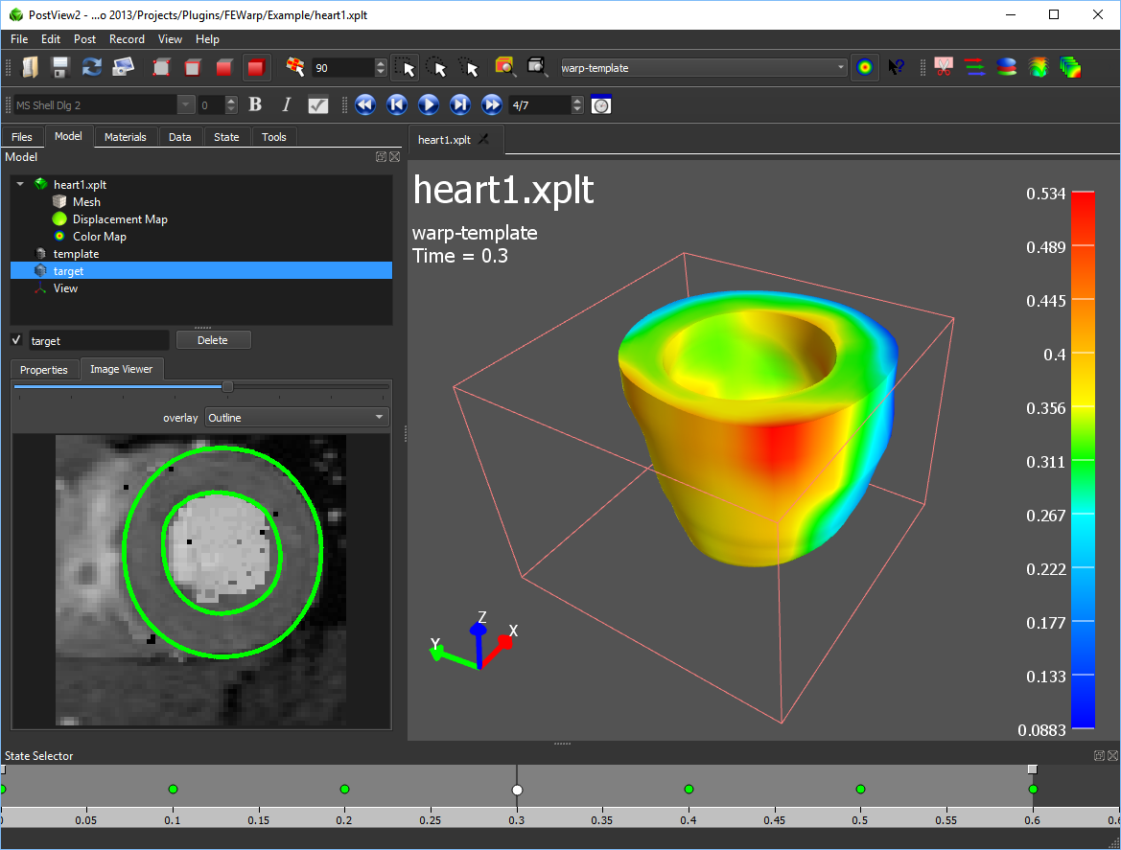
When selecting an image set in the model tree, a second tab appears, labeled “Image Viewer”, next to the “Properties” tab (see Figure 2). Here, you can scroll through the image stack using the slider at the top of the image viewer. You can also add an overlay to the image, which draws an intersection of the image slice with the model on to the image. Currently, only the “Outline” option is available, which draws a line that intersects the surface of the model.
Figure 2. The PostView UI with image data loaded and the Model Viewer panel shown. Each image set is represented by a separate item in the model tree and a colored box outline in the Graphics View. For image sets, the Model Viewer will also display the “Image Viewer” tab below the model tree, where the user can scroll through the slices of the image stack using the slider at the top of the image viewer.
An image set can be deleted from the model by selecting the corresponding item in the model tree and then clicking the Delete button below the model tree. This operation cannot be undone. The only way to recover the image data is by reloading it as described in section 3.

Visualizing image data in 3D
PostView provides several mechanisms for rendering the image data in the Graphics View, namely via a volume renderer, image slicer, or an image isosurface. Each image data can have multiple image renderers, but only one of the image sets should have a volume renderer. In the next section, the image renderers will be described in more detail.

The Volume Renderer
A volume renderer can be attached to an image data by first selecting the corresponding item in the model tree and then selecting the menu Post\Volume Render. There is also a toolbar button that does the same.
Figure 3. A volume rendered image of a data set.
A volume renderer will render a volumetric image onto the Graphics View. The image intensity will be mapped to an alpha value, which defines the opacity of the image so that parts of the image will be semi-transparent. Similarly, a color transfer function is used to map image intensity to a color map and provide color to the rendered image (Figure 3).
Figure 4. A volume renderer was added to an image data set. The properties can be edited in the Model Viewer.

The volume renderer will show up as a child item of the image data in the model tree (Figure 4). The properties of the volume renderer can be edited in the properties tab below the model tree. The following properties are defined:
- alpha scale: a scale factor for the alpha channel. Smaller values make the image more transparent.
The following two parameters define a linear stretch filter to the image intensity.
- min intensity: minimum intensity value. A pixel with this value will be given a new intensity of 0. Pixels with lower values will be given an alpha of Amin.
- max intensity: maximum intensity value. A pixel with this value will be given a new intensity value of 255. Pixels with higher values will have their alpha value set to Amax.
The color of the voxel in the final rendering will be determined via a colormap that maps the grayscale value to a color.
- Color map: select the color map that will be used to colorize the image.
- Ambient Color: Color offset added to each voxel.
Another linear stretch filter is applied to the alpha value of each voxel, which determines its opacity. If the voxel’s original intensity value fell outside the range defined by min intensity and max intensity, the new alpha value will be defined by either Amin or Amax, depending on which end of the interval it fell. The alpha value of all the other voxels will be mapped between min alpha and max alpha.
- min alpha: the alpha value given to pixels with minimum (stretched) intensity.
- max alpha: the alpha value given to pixels with maximum (stretched) intensity.
- Amin: the alpha value given to pixels that fell below the intensity range.
- Amax: the alpha value given to pixels that fell above the intensity range.
The volume renderer can also simulate the effect of shading by calculating a “normal” at each voxel, which is then used to calculate an attenuation factor, based on the position of the light.
- Lighting effect: Turn on or off the shading effect.
- Lighting strength: scale factor for the shading effect (value between 0 and 1).

The Image Slicer
An image slicer can be attached to an image data by first selecting the corresponding item in the model tree and then selecting the menu Post\Image Slicer. There is also a toolbar button that does the same.
Figure 5. The image slicer will show a slice of the image data along one of the three principal axes. Multiple image slicers can be attached to the same image set. In this figure, three slicers show three different planes of the same image set.
The image slicer will show a slice through the image data at a particular position. The slice can be oriented along the X, Y, or Z-plane. Multiple image slicers can be attached to the same image set, which can be used to display multiple slices simultaneously (Figure 5). The image slicer defines the following properties, which can be edited in the Model Viewer.
- image orientation: The principal axis of the image plane.
- image offset: the position of the slice relative to the image set (value from 0 to 1).
The color of the image can be changed via the following parameter.
- Color map: select the color map that colors the image.

Image Isosurface
The image isosurface renderer will render an isosurface of the image data, i.e. a surface defined by a constant image value. The user can set the iso-surface value, as well as several other parameters described below.
To add an image isosurface renderer, select the menu “Post\Image Isosurface” or the corresponding button on the main toolbar.
Figure 6. The image isosurface renderer will draw a surface of constant image intensity value.
The following parameters can be set for the image isosurface renderer.
- isosurface value: The value that defines the isosurface.
- smooth surface: Smooth the surface or render as flat triangles.
- surface color: Set the color of the surface mesh.
- close surface: close the surface that intersects the image boundaries.
- invert space: Render the negative of the image space.

